Student Exploration: Force and Fan Carts

Vocabulary: force, friction, position, speed

Prior Knowledge Questions (Do these BEFORE using the Gizmo.)

- If you are pushing a shopping cart and you start pushing harder, what happens?

_________________________________________________________________________

- What happens to a shopping cart if you get it rolling and then release it?

_________________________________________________________________________

Gizmo Warm-up

- In the Gizmo, turn the fan Off. Click Play (). Did the cart move? _________________

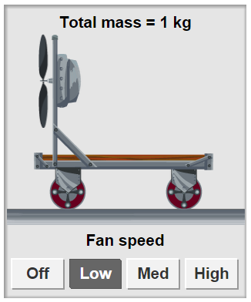
- Click Reset (). Press the Low fan speed button to turn on the fan. Click Play. What happened?
___________________________________________

- A force is something that causes change in motion. What provided the force that made the cart speed up?

___________________________________________

- The speedometer shows the cart’s speed, or how fast it moves. A speed of 30 cm per second means the cart moves 30 cm every second. What was the final speed of the cart?

_________________________________________________________________________

- Friction is a force that works against motion as surfaces rub each other. Click Reset. Select the No Friction surface. Click Play. What was the final speed this time?

_________________________________________________________________________

Activity A:  Force and motion | Get the Gizmo ready:  - Click Reset.  - Change the Surface to Wood.  - Be sure there are no objects on the cart.  - The Fan speed should be set to Low. | 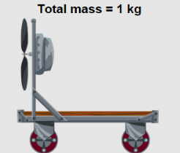

Question: How does force affect motion?

- Run Gizmo: Press Play. What was the final speed of the cart? _______________________

- Predict: Would the cart’s final speed be higher or lower if the fan were set to Medium instead of Low? ____________________________________________________________

- Experiment: Click Reset. Change Fan speed to Medium. Click Play.

What was the cart’s final speed? _______________________

- Draw conclusion: Did the cart speed up more quickly with the fan on Low or Medium?

_________________________________________________________________________

- Generalize: On Medium the fan provides more force than on Low. Make two rules by filling in the blanks below. (Put the same word in both blanks.)

Force causes the ________________ of the cart to change.

If more force is used, the ________________ of the cart changes more quickly.

- Predict: Select the DATA tab. Choose Bar graph or Line graph. This graph shows the cart speed over time. How would the graph be different if the fan were on High? Why?

_________________________________________________________________________

_________________________________________________________________________

- Test: Check your prediction with the Gizmo. What do you observe? ___________________

_________________________________________________________________________

- Extend: Design an experiment to test the effect of force on a loaded cart. You can choose any surface and any object to load onto the cart. On the back of this sheet or an additional sheet, report your question, prediction, procedure, observations, and conclusion.

Activity B:  Running out of steam? | Get the Gizmo ready:  - Click Reset.

Question: Why do objects slow down when there is nothing pushing them?

- Observe: Use the Gizmo to explore the question above. Try different objects and surfaces. Each time, turn the fan Off while the cart is moving. (You may find it helpful to pause the Gizmo with the Pause () button, turn the fan off, and then click Play to restart.)

- Form hypothesis: What causes an object to slow down after no longer being pushed?

_________________________________________________________________________

- Predict: Set Fan speed to High. Based on your hypothesis, circle all surfaces that will cause a moving cart to slow down after the fan is turned off. (You may circle more than one.)

No Friction Metal Cement Wood

- Test: Run the trials using the Gizmo. Which surface(s) caused the cart to slow down?

No Friction Metal Cement Wood

- Draw conclusion: What causes objects to slow down when they are no longer pushed?

_________________________________________________________________________

- Think about it: Imagine the track in the Gizmo went on forever. If there were no friction, how long would it take the cart to stop after you turned off the fan? Explain.

_________________________________________________________________________

_________________________________________________________________________

_________________________________________________________________________

- Analyze: Which surface in the Gizmo has the most friction? Explain how you can tell.

_________________________________________________________________________

_________________________________________________________________________

Activity C:  Patterns in  motion | Get the Gizmo ready:  - Click Reset. Select No friction.  - Place only the soda and book on the cart.  - Set the Fan speed to High.  - Select No Friction. | 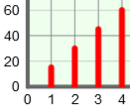

Question: Are there any patterns in the motion of objects?

- Run Gizmo: Be sure No friction is selected. Click Play. After about 3 seconds, turn the fan Off. (We recommend that you click Pause, turn the fan off, and then click Play to restart the Gizmo.)

- Observe: Select the DATA tab. Select Position. The position of the cart is its location (how far from the start line). What pattern do you see in the position data after the fan is off?

_________________________________________________________________________

_________________________________________________________________________

- Connect: How is the final speed of the cart related to the pattern in the position data?

_________________________________________________________________________

- Analyze: Why does that pattern happen? (Hint: Think about what “cm per second” means.)

_________________________________________________________________________

_________________________________________________________________________

- Observe: Select Speed. What pattern do you see in the speed data, after the fan is off?

_________________________________________________________________________

_________________________________________________________________________

- Connect: How does the bar graph (or line graph) show the pattern you found?

_________________________________________________________________________

_________________________________________________________________________

- Generalize: Fill in the blank below to state a rule based on what you saw.

If there is no force, the _______________ does not change at all.

